Fundamentals of Programing

Lab Manual # 10

**Lab Instructor:** Muhammad Affan

## Student Name: *MUHAMMAD UZAIR*

## CMS ID: 477228

# Task 1:

#include<iostream>

#include<vector>

using namespace std;

int main(){

int input, i;

vector<int> v;

for(i=0; i<10; i++){

cout<<"Enter a Value to Add to Vector's "<<i<<" index: ";

cin>>input;

v.push_back(input);

}

cout<<endl<<"Vector Currently Holding: ";

for(i=0; i<10; i++){

cout<<v.at(i)<<", ";

}

v.erase(v.begin()+5);

v.insert(v.begin()+5, 5);

cout<<endl<<"Updated Vector: ";

for(i=0; i<10; i++){

cout<<v.at(i)<<", ";

}

}

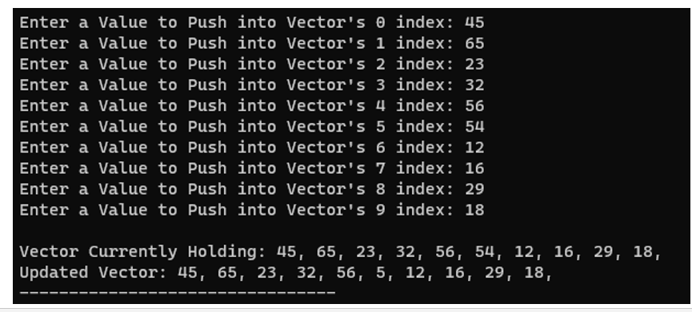

**Task 2:**

#include<iostream>

#include<vector>

#include<string>

using namespace std;

int find_mean(vector<int> v){

int sum=0, size=v.size();

for(int i=0; i<v.size(); i++){

sum=v[i]+sum;

}

int mean=sum/v.size();

return mean;

}

int find_median(vector<int> v){

// ... (unchanged)

int find_mode(vector<int> v){

// ... (unchanged)

}

void students_mode(vector<string> v, vector<int> g, int mode){

// ... (unchanged)

}

int main(){

vector<string> names;

vector<int> grades;

int i,j,input, num;

string name;

cout<<"Enter Number of Students to be Inputted: ";

cin>>num;

for(i=0; i<num; i++){

system("cls");

cout<<"Enter the Name of Student: ";

cin>>name;

names.push_back(name);

cout<<endl<<"Enter Grade of Student in Percentage: ";

cin>>input;

grades.push_back(input);

}

system("cls");

int mean=find_mean(grades);

cout<<endl<<"Mean is: "<<mean<<endl;

int median=find_median(grades);

cout<<"Median is: "<<median<<endl;

int mode=find_mode(grades);

cout<<"Mode is: "<<mode<<endl;

students_mode(names, grades, mode);

}

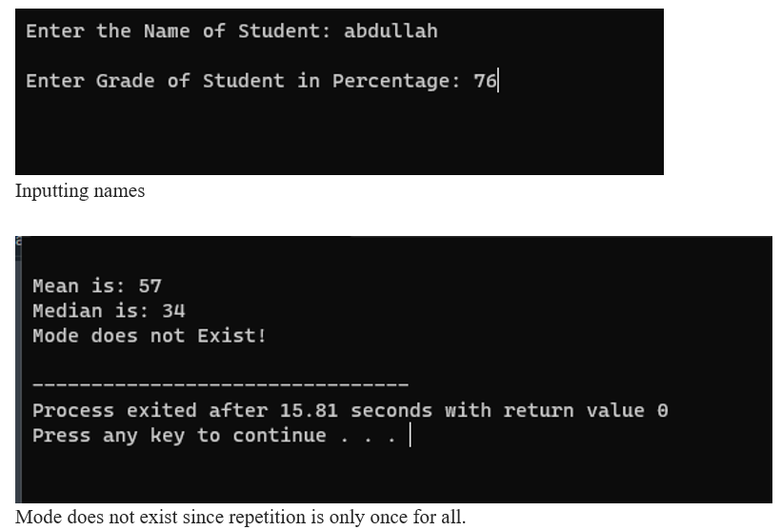

# Task 3:

#include<iostream>

#include<cmath>

using namespace std;

class Triangle{

public:

int length1 = 3;

int length2 = 4;

int length3 = 5;

int perimeter(){

return length1 + length2 + length3;

}

double area(){

int s = perimeter() / 2;

return sqrt(s * (s - length1) * (s - length2) * (s - length3));

}

};

int main(){

Triangle task3;

int perimeter;

double area;

perimeter = task3.perimeter();

area = task3.area();

cout<<"Area is: "<<area<<endl;

cout<<"Perimeter is: "<<perimeter<<endl;

}

}

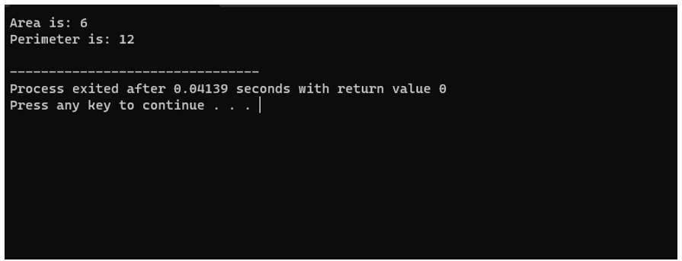

# Task 4:

#include <iostream>

#include <string>

using namespace std;

struct Employee {

string name;

double salary;

int hoursWorkedPerDay;

};

int main() {

const int numEmployees = 10;

Employee employees[numEmployees];

for (int i = 0; i < numEmployees; ++i) {

cout << "Enter name for employee " << i + 1 << ": ";

cin >> employees[i].name;

cout << "Enter salary for employee " << i + 1 << ": ";

cin >> employees[i].salary;

cout << "Enter hours of work per day for employee " << i + 1 << ": ";

cin >> employees[i].hoursWorkedPerDay;

cout << endl;

}

for (int i = 0; i < numEmployees; ++i) {

if (employees[i].hoursWorkedPerDay >= 12) {

employees[i].salary += 150;

} else if (employees[i].hoursWorkedPerDay >= 10) {

employees[i].salary += 100;

} else if (employees[i].hoursWorkedPerDay >= 8) {

employees[i].salary += 50;

}

}

cout << "Employee Details:" << endl;

for (int i = 0; i < numEmployees; ++i) {

cout << "Name: " << employees[i].name << ", Final Salary: $" << employees[i].salary << endl;

}

}S

# 

